1. How long did you spend doing this assignment?
   1. I spent about a week and 3 days; I started working on the program a week after it was uploaded on Blackboard.
2. The name of the directory where your files are?

<https://cssrvlab01.utep.edu/Classes/cs5339/amnavarro2/new_lab2_secure_web-main/main_page.php>

1. What problems (if any) did you encounter in this assignment, and if yes, how did you solve the problems?
   1. The only problems I encountered in this assignment was connecting to the UTEP database through my code which was giving me an access restricted error message. I soon realized that the reason why that wouldn’t work was because I was testing through my local host. To fix it, I uploaded my code to the UTEP server and then tested the code through the website which allowed the code to access my database.
   2. I then realized I wasn’t correctly using the verification function since I wasn’t comparing the password in the database. I was later able to fix the mistake I had done after a couple of minutes, but required me to change the structure of my old verification method for the passwords.
2. Comment on how useful this assignment was to learn about authentication by password on web-based systems.
   1. It allowed me to learn of a secure way to encrypt a password by using the password_hash function which I never knew had existed. But this function will be used for sure when having users get authenticated when logging in.

NOTE I MADE THESE USERS within the users and admin tables FOR TESTING PURPOSES.

USE THESE as they are the current ones that actually work to meet the requirements, anything else was for testing. If you want more accounts go through the website to be able to create users in the visitors page and inside the admin page there is an option to create other admin accounts.

Users :

Username: nimda; Password: nimda

Admin:

Username: admin1; Password: admin1

Username: Nimda2; Password:Nimda2

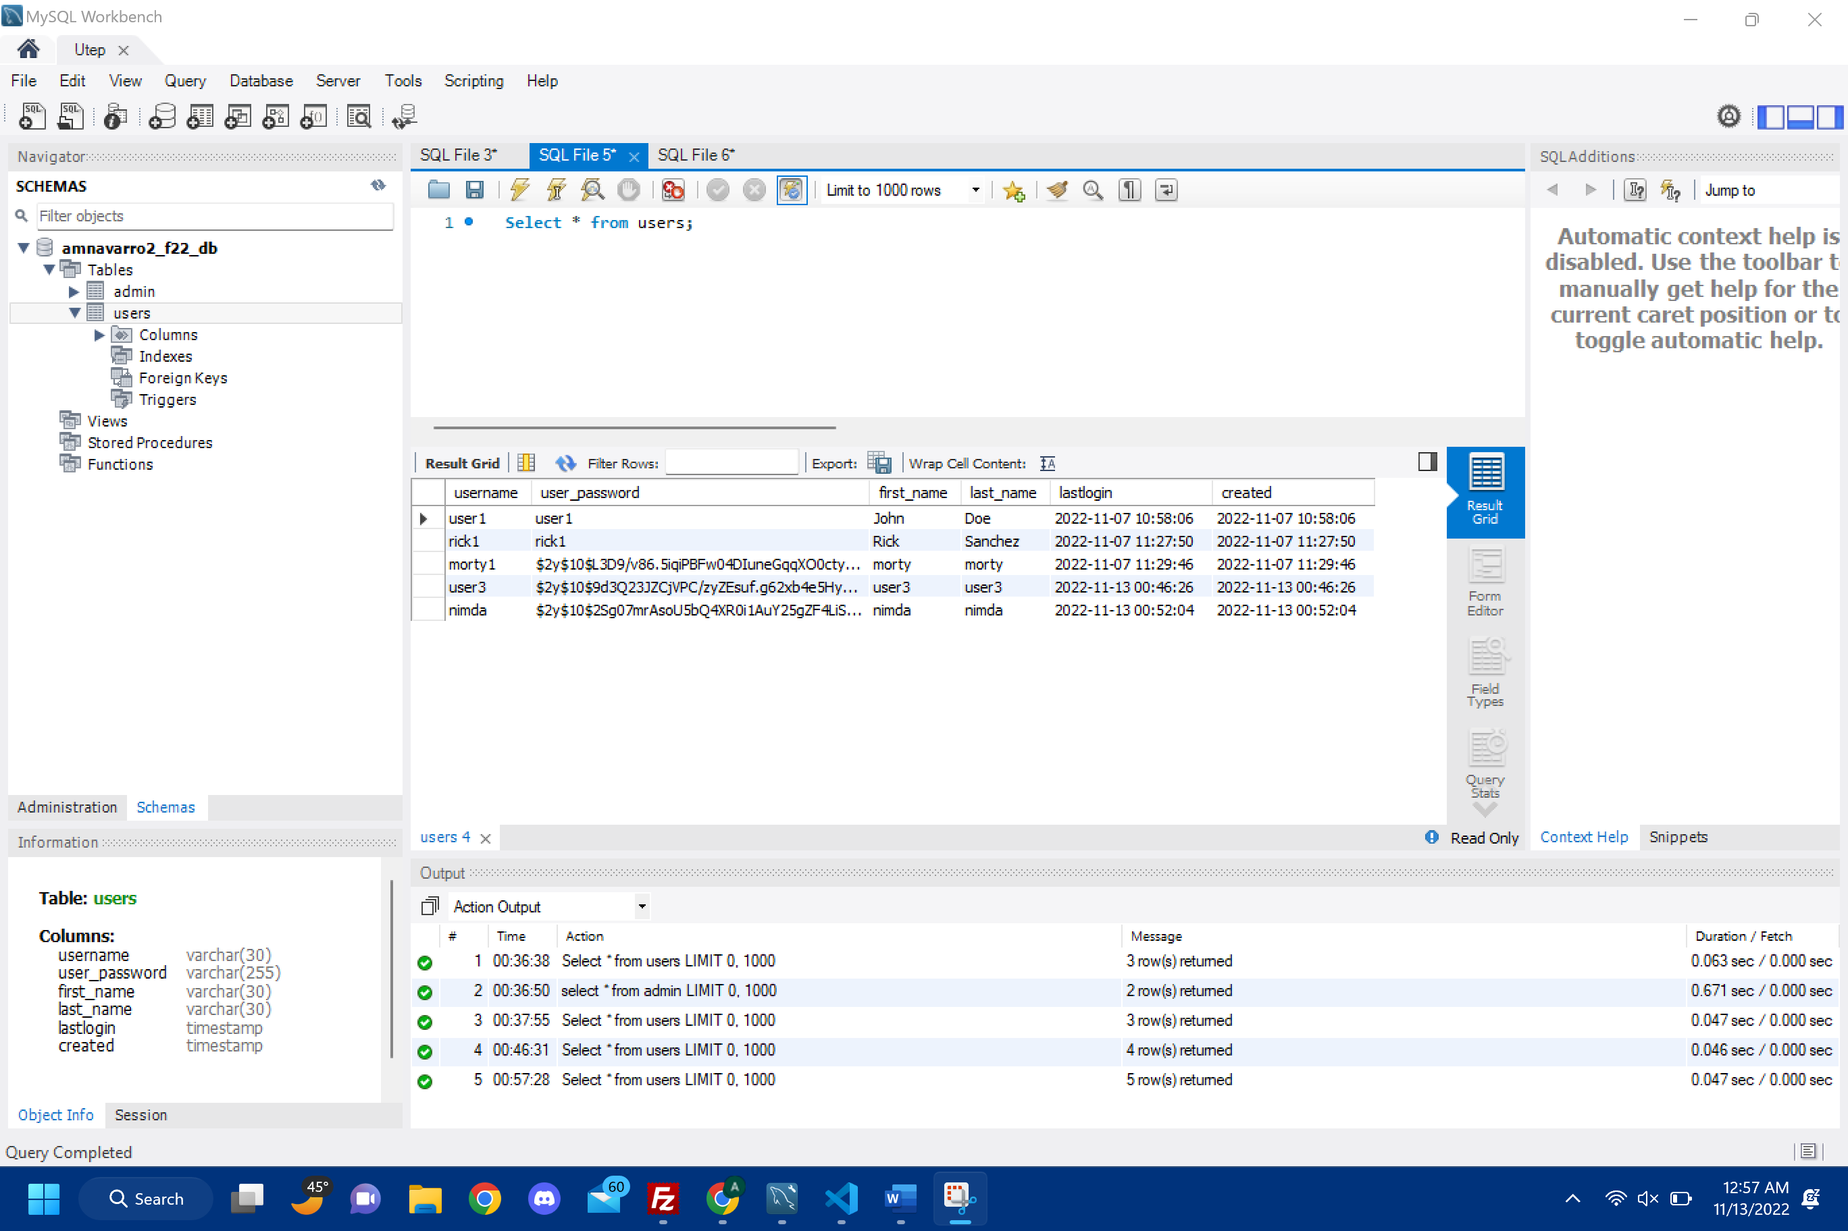

example from my workbench as proof for the users table.

example from my workbench as proof for the admin table.

NOTE: The Create tables functions were implemented through MySQL workbench instead of actually doing it through php code.